Semester 1 (Unit 1) Examination, 2015

Question/Answer Booklet

MATHEMATICS METHODS

Section Two: Calculator-assumed

Student Name/Number: ______________________________________________

Teacher Name: ______________________________________________

Time allowed for this section
Reading time before commencing work: ten minutes
Working time for this section: ninety minutes

Materials required/recommended for this section
To be provided by the supervisor: This Question/Answer Booklet
Formula Sheet (retained from Section One)

To be provided by the candidate:
Standard items: pens (blue/black preferred), pencils (including coloured), sharpener, correction fluid/tape, eraser, ruler, highlighters
Special items: drawing instruments, templates, notes on ____ unfolded sheets of A4 paper, and up to three calculators approved for use in the WACE examinations

Important note to candidates
No other items may be taken into the examination room. It is your responsibility to ensure that you do not have any unauthorised notes or other items of a non-personal nature in the examination room. If you have any unauthorised material with you, hand it to the supervisor before reading any further.

Structure of this paper

Section | Number of questions available | Number of questions to be answered | Working time (minutes) | Marks available | Percentage of exam
Section One: Calculator-free | 7 | 7 | 50 | 60 | 35
Section Two: Calculator-assumed | 11 | 11 | 90 | 90 | 65
 |  |  |  |  | 100

Instructions to candidates

- The rules for the conduct of School exams are detailed in the _______________________________________School/College assessment policy. Sitting this examination implies that you agree to abide by these rules.

- Write your answers in this Question/Answer Booklet.

3. You must be careful to confine your responses to the specific questions asked and to follow any instructions that are specific to a particular question.

- Spare pages are included at the end of this booklet. They can be used for planning your responses and/or as additional space if required to continue an answer.
  - Planning: If you use the spare pages for planning, indicate this clearly at the top of the page.
  - Continuing an answer: If you need to use the space to continue an answer, indicate in the original answer space where the answer is continued, i.e. give the page number. Fill in the number of the question that you are continuing to answer at the top of the page.

- Show all working clearly. Your working should be in sufficient detail to allow your answers to be checked readily and for marks to be awarded for reasoning. Incorrect answers given without supporting reasoning cannot be allocated any marks. For any question or part question worth more than two marks, valid working or justification is required to receive full marks. If you repeat any question, ensure that you cancel the answer you do not wish to have marked.

- It is recommended that you do not use pencil, except in diagrams.

- The Formula Sheet is not to be handed in with your Question/Answer Booklet.

Section Two: Calculator-assumed (90 Marks) Weighting 65%

This section has (eleven) 11 questions. Answer all questions. Write your answers in the spaces provided. Spare pages are included at the end of this booklet.

Suggested working time: 90 minutes.

Question 8 (9 marks)
Determine the equation
(a) of the line passing through the points 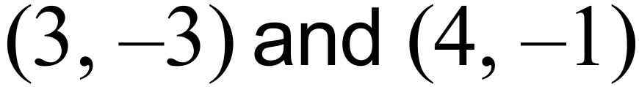 (2 marks)

(b) of the line passing through the point 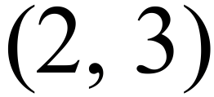 and parallel to 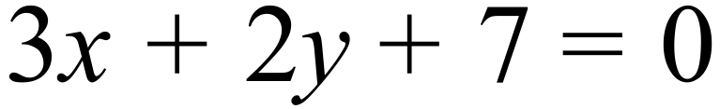 (2 marks)

(c) of the line passing through the point 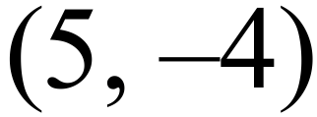 and perpendicular to 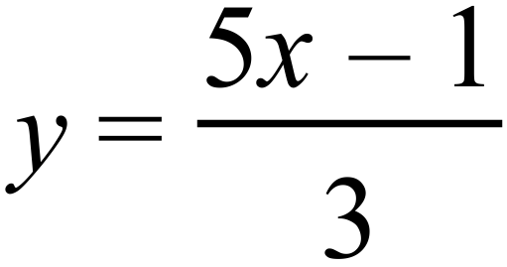 (3 marks)

(d) of the line which is the reflection of the line 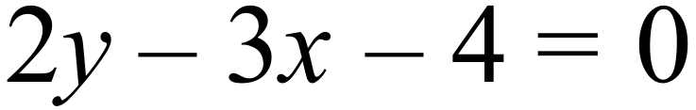 in the y-axis (2 marks)

Question 9 (8 marks)
A researcher gathered the necessary information and developed a simulation to represent the number of attempts that people make to find the correct way through a particular maze associated with a digital game.
The graph of the result of 100 simulations is recorded below.
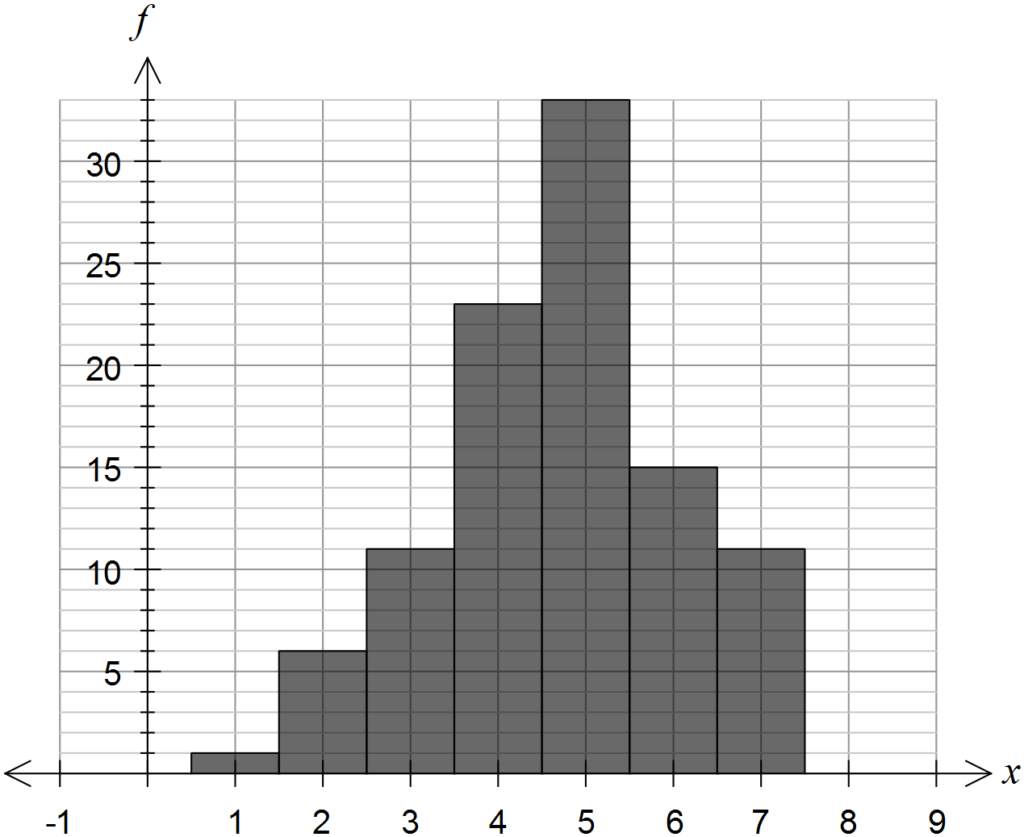
: represents the event that a randomly selected person takes 5 attempts to navigate the maze successfully.
: represents the event that a randomly selected person takes less than 5 attempts to navigate the maze successfully.
- Determine:
- (1 mark)

- (2 marks)

- (1 mark)

- Make a statement, with supporting argument, about whether events are independent, mutually exclusive or neither. ( 2 marks)

- Given , determine the probability that a person takes 5 attempts. (2 marks)

Question 10 (6 marks)

In the diagram  , 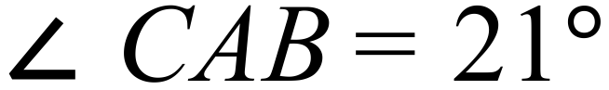 and the exterior angle at B is 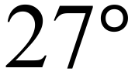 .

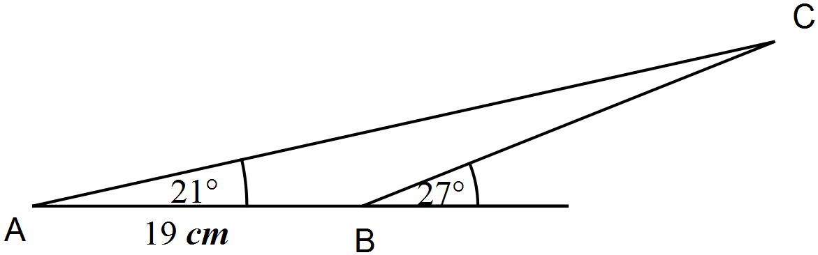

- Calculate the length of BC. (2 marks)

- Calculate the area of triangle ABC. (2 marks)

- Calculate the length of the line from A to the mid-point of BC. (2 marks)

Question 11 (5 marks)

The Wombat cricket club selects 11 of its 25 members at random to form a team to play in a charity match against a rival club.

- How many different teams are possible? (2 marks)

- In how many ways can the team be selected if the two best players are not included?
(1 mark)

- Determine the probability that the two best players are not selected. (2 marks)

Question 12 (12 marks)
A weight on the end of a spring oscillates up and down.
The distance cm of the weight above the equilibrium position is given by:

, where is the time in seconds.

- What is the position of the weight at time ? (1 mark)

- How many times is the weight at the equilibrium position during the first 5 seconds? (2 mark)

- What do negative values of represent? (1 mark)

- On the axes provided below, draw a graph of for
(3 marks)
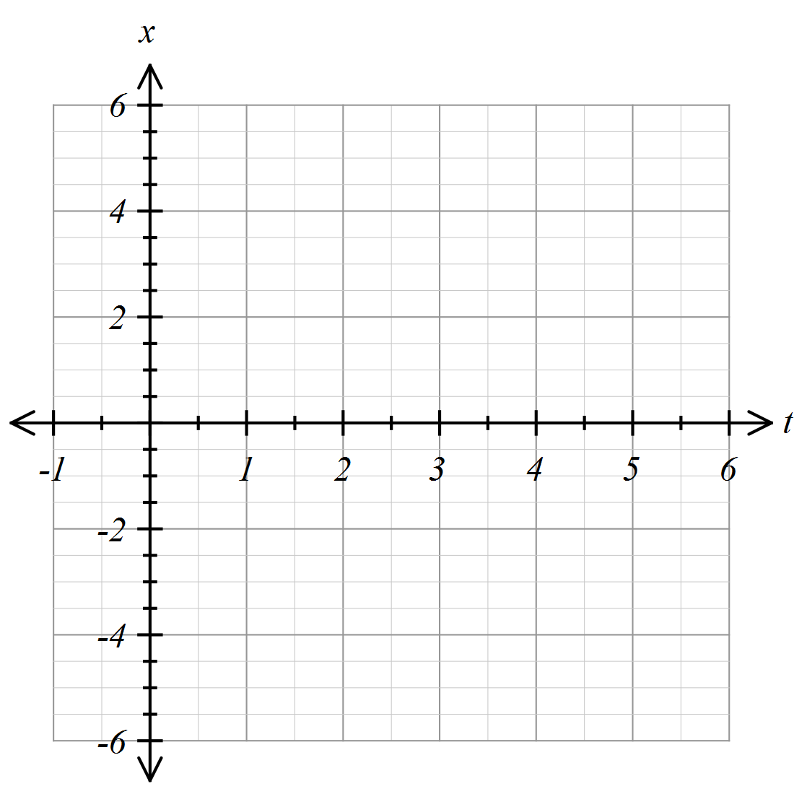

- On your graph (drawn in part (d)), indicate those points that correspond to the weight being more than 2cm from the rest position. (2 marks)

- Determine for what fraction of the time the weight is more than 2 cm from the rest position.
(3 marks)

Question 13 (8 marks)

- For a given set of numbers the set of points is defined as follows:

- State the Domain of (1 mark)

- State the Range of. (2 marks)

- If the set is redefined as follows:

- List the elements of (2 mark)

- State the Range of. (1 marks)

- Comment on whether either of would qualify to be called a function? Justify your comment. (2 marks)

Question 14 (9 marks)

On the grid below, are drawn the graphs of a circle and a parabola.
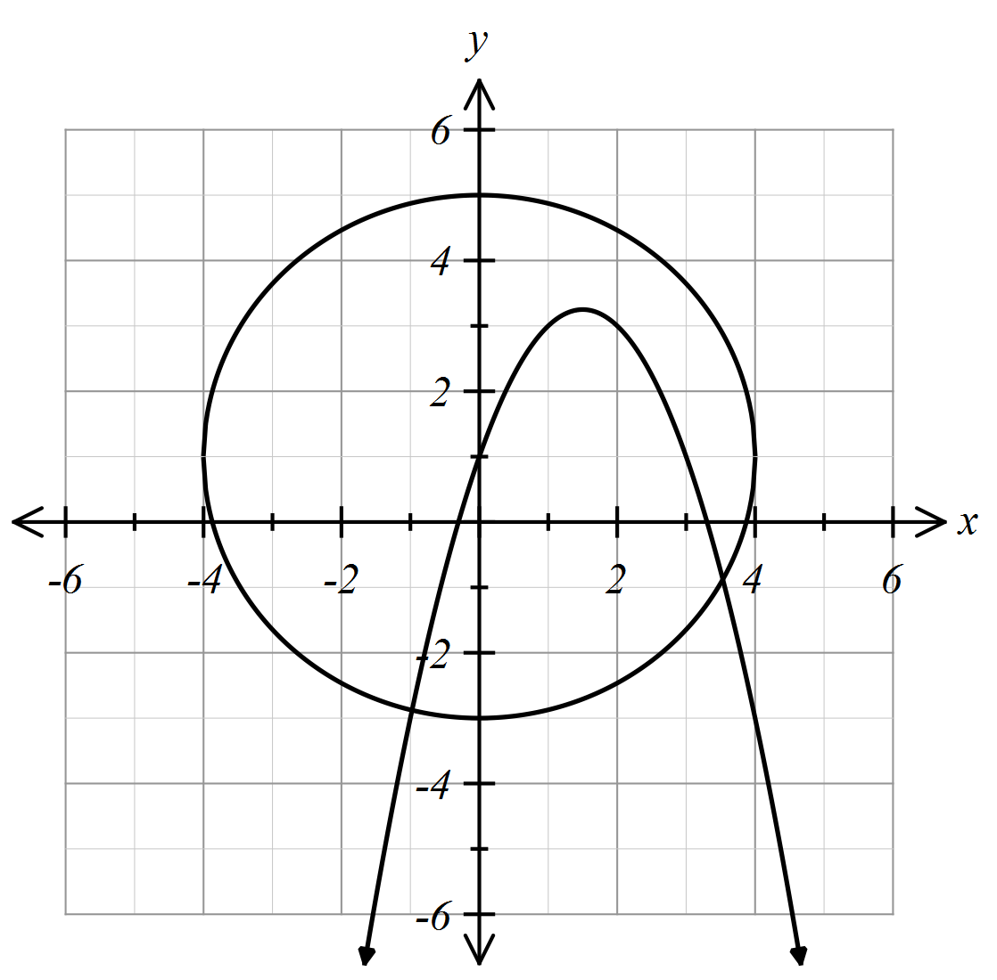

- State the equation of the circle (2 marks)

- State the equation of the parabola in the form (5 marks)

- Show, algebraically, using the discriminant, that the intercepts of the parabola will be irrational. (2 marks)

Question 15 (6 marks)

The cross-section of a wooden hand rail is formed by the intersection of two quadratic functions shown below. The upper curve is modelled by the equation 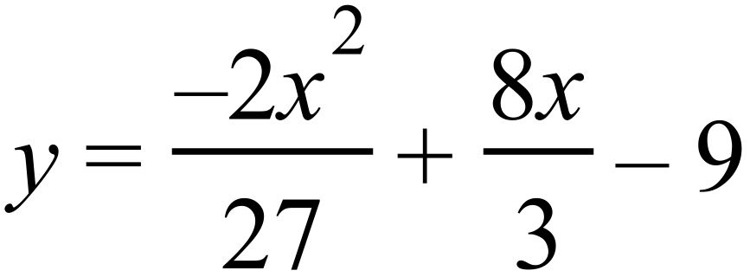 . The equation of the lower curve is a quadratic of the form 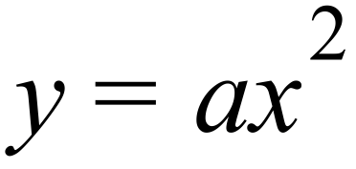 . The two curves meet at 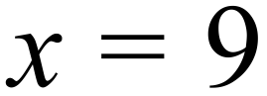 .
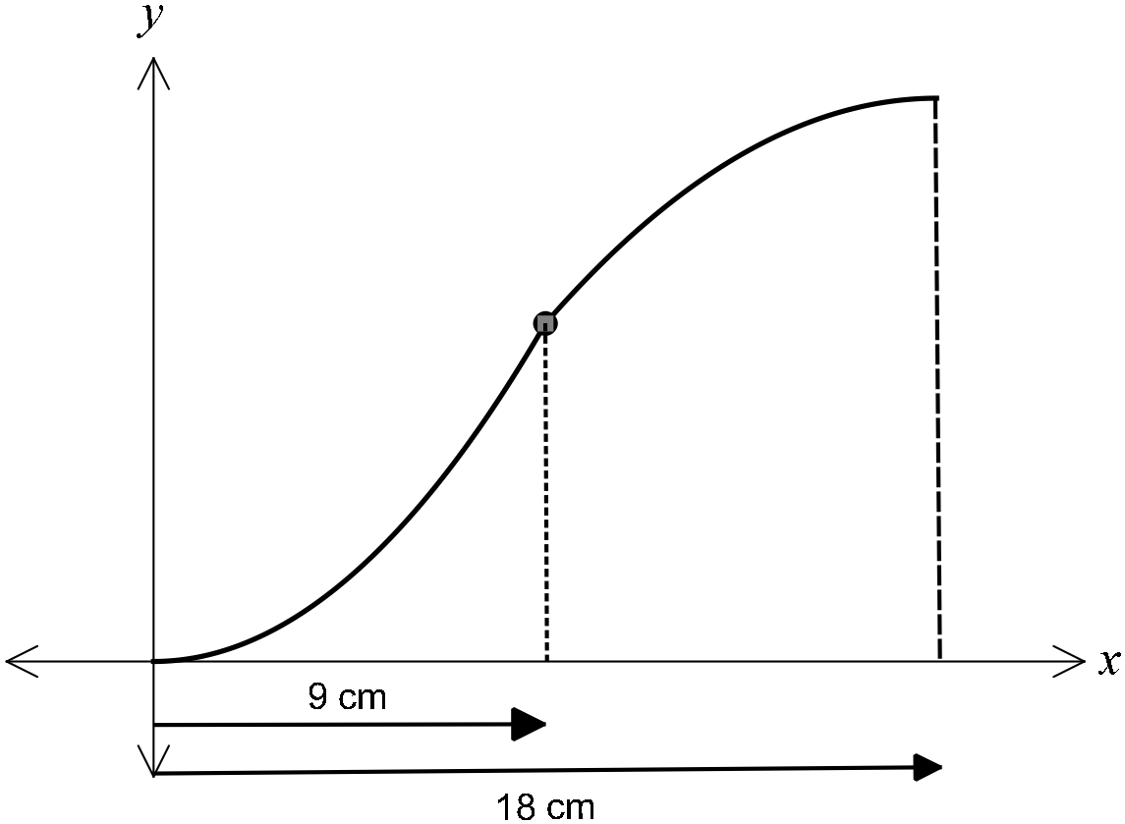

(a) Determine the coordinates of the point where the two curves meet. (2 marks)

(b) Determine and hence state the equation of the lower curve (2 marks)

(c) If the hand rail was moved up 3 cm, determine the new equations of the upper and lower curves. (2 marks)

Question 16 (8 marks)

(a) Consider the function 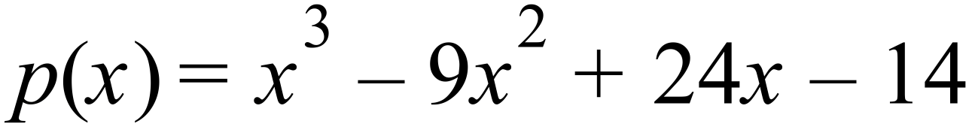
(i) How many solutions does the equation 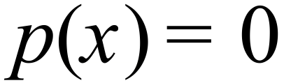 have? (1 mark)

- For what values of k will the equation 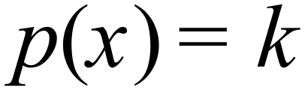 have two distinct values of?
(2 marks)

(b) If , determine the values of a, b, c and d, and hence factorise the cubic expression fully. (5 marks)

Question 17 (12 marks)
For a particular game of chance, a coin is tossed randomly onto a board. The board has coloured regions according to the diagram below.
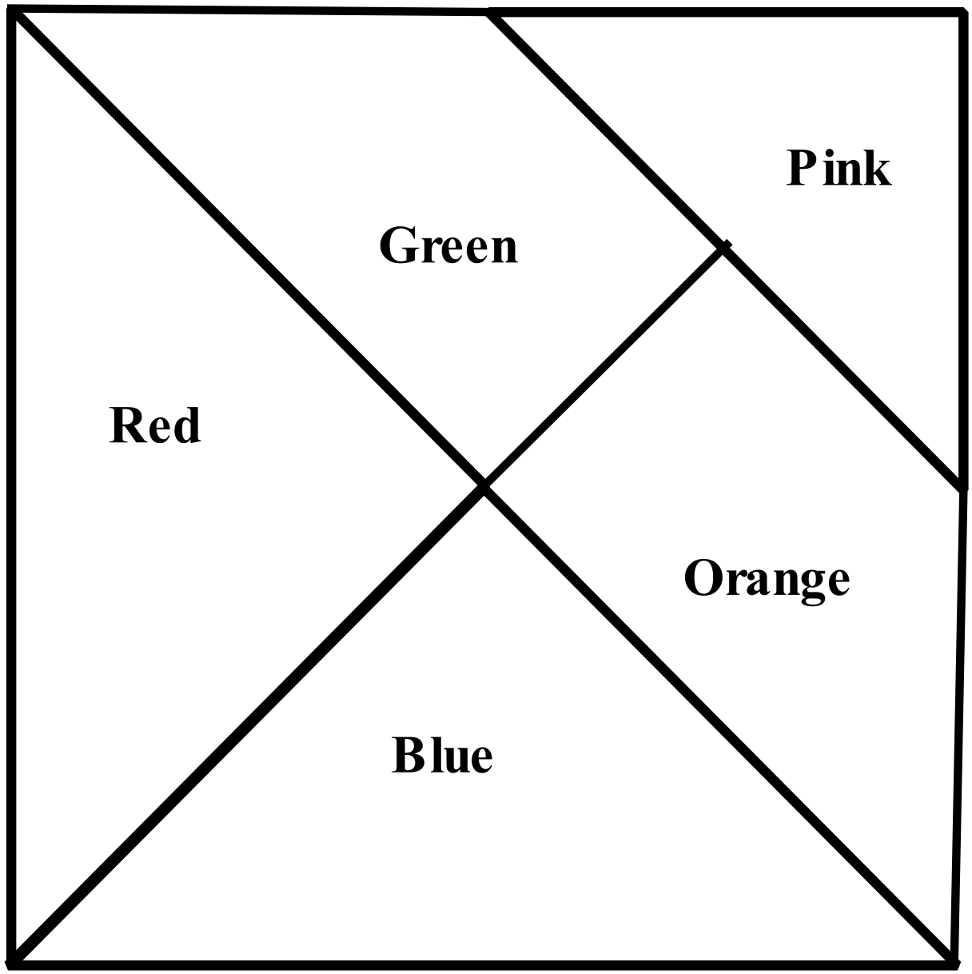
Lines that look like they intersect at the middle of a line segment, actually do so.
Determine the probability that
- The coin lands on Blue (2 marks)

- The coin lands on Blue or Orange (2 marks)

- The coin is a head and lands on Green (2 marks)

- The coin is tail up, given that it lands on Blue or Pink (2 marks)

- If a second coin is tossed, it lands on the same colour as the first. (4 marks)

Question 18 (7 marks)

- Given , show how to deduce the formula for
by letting (2 marks)

- Consider a rope fixed at B and tightly wrap around a disc A as shown in the diagram below.

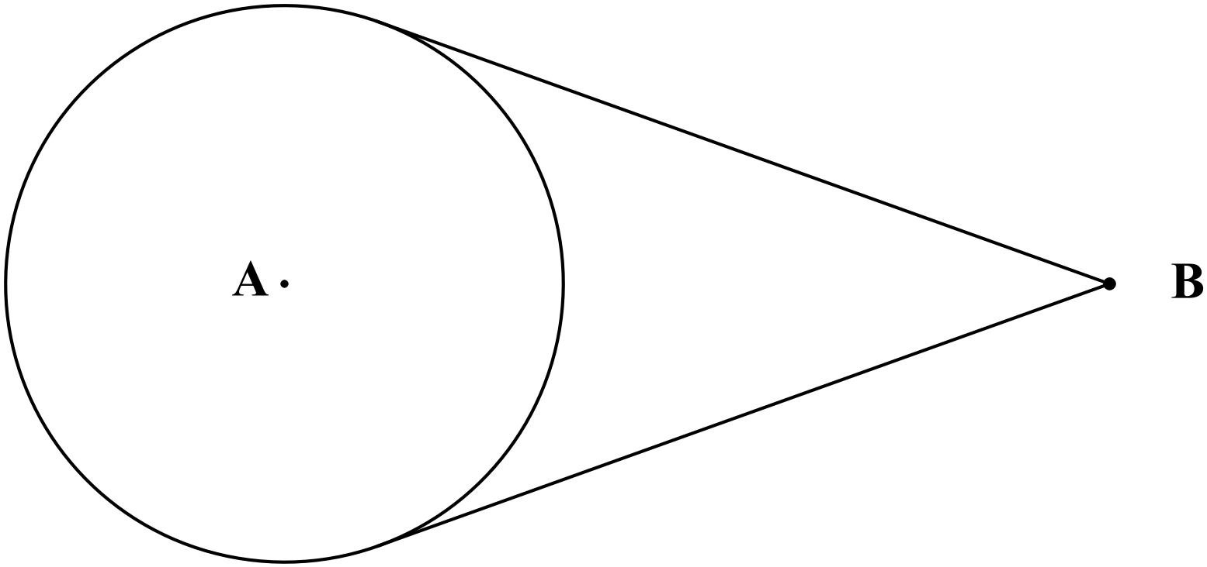
Disc A has a radius of 10cm. If the distance of B from the nearest edge of disc A is twice the radius of disc A, determine the length of the rope. (5 marks)

End of Questions
Additional working space
Question number: __________________

Acknowledgements

© MAWA, 2015
This examination is Copyright but may be freely used within the school that purchases this licence.
- The items that are contained in this examination are to be used solely in the school for which they are purchased.
- They are not to be shared in any manner with a school which has not purchased their own licence.
- The items and the solutions/marking keys are to be kept confidentially and not copied or made available to anyone who is not a teacher at the school. Teachers may give feedback to students in the form of showing them how the work is marked but students are not to retain a copy of the paper or the marking guide until the agreed release date stipulated in the purchasing agreement/licence.
Published by The Mathematical Association of WA
12 Cobbler Place, MIRRABOOKA 6061

